Dr. Wendy Wells, MD, Chair of Department of Pathology, requests the following Clinical Laboratory Update be distributed to the Physician Staff, House Staff,

Physician Assistants, Nurse Practitioners

**Clinical Laboratory Update**

Date: February 17, 2020

From: Gregory J. Tsongalis, PhD, Director, CGAT

Isabella W. Martin, MD, Director, Microbiology

Joel A. Lefferts, PhD, Assistant Director, CGAT

Samantha Allen, MB(ASCP)CM, Supervisor, CGAT

Heather Steinmetz, MB(ASCP)CM, Manager, CGAT

Subject: Acute Tick-Borne Infection Panel

Beginning February 18, 2020, the DHMC Department of Pathology and Laboratory Medicine’s Laboratory for Clinical Genomics and Advanced Technology (CGAT) will be offering a new DNA-based **Acute Tick-Borne Infection Panel (LAB4221)**.

This test can be used to detect DNA from the non-Lyme tick-associated pathogens present in the northeastern USA (*Anaplasma phagocytophilum*, *Babesia microti* and *Borrelia miyamotoi*) as well as *Ehrlichia chaffeensis* which is most prevalent in the southeastern and south central USA. This panel should be considered for patients with a known or suspected history of tick exposure who are presenting with a febrile illness in tick season. In addition to fever/chills, other nonspecific symptoms caused by these pathogens can include myalgia, headache, nausea, and fatigue.

This test is validated for use with the following specimen type:

peripheral blood (lavender-top tube, EDTA).

*Please store/transport specimens at 4°C to room temperature (Do not freeze)*

Expected turnaround time: 2 days from time of receipt in lab (testing not performed on weekends)

This test **DOES NOT** detect *Borrelia burgdorferi*, the causative agent of Lyme disease. Serologic testing should be considered if Lyme disease is suspected (Lyme Disease Antibody Screen Serum LAB3623).

Please refer to the testing algorithm below to determine appropriate testing options.

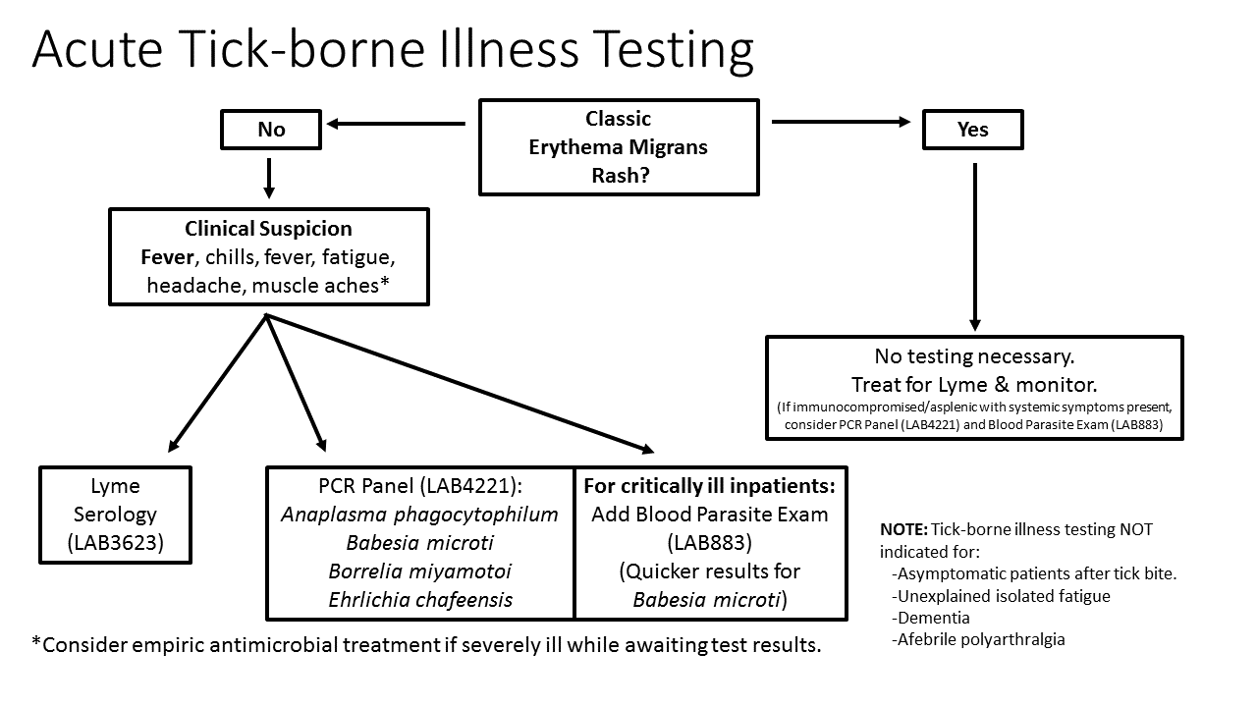

* eDH orderable: Orders can be placed using the test name “Acute Tick Borne Infection Panel”:
* eDH reporting: Results can be viewed in “Results Review” under Laboratory Results>Infectious Disease>MISC

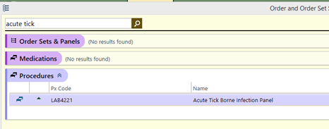 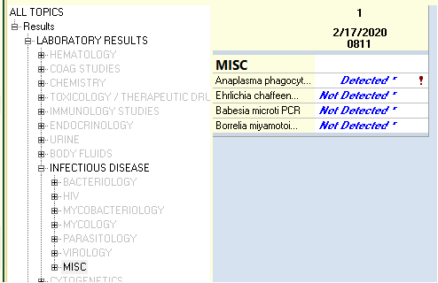

For questions or additional information please contact:

Samantha Allen, CGAT Supervisor, extension 5-8220

Joel Lefferts, PhD, CGAT Assistant Director, extension 5-8116

Isabella Martin, MD, Director, Microbiology, extension 5-4984