Date: 6/22/2022

From: Mark A. Cervinski, PhD

Director of Clinical Chemistry

To: All Dartmouth Health Providers

RE: Update to Natera Panorama Screen Requirements (Lab4264, <https://www.natera.com/womens-health/panorama-nipt-prenatal-screening/>)

Starting Monday, June 27 2022, “Natera Panorama Screen” orders and results will be interfaced.

* Orders must originate in Epic for the interface to function properly.
* LAB4264 may need to be removed from personal preference lists then re-saved to pick up the addition of the new required ask at order entry questions.
* Non-DH orders (OPW) should be placed as miscellaneous orders.
* Natera account numbers are clinic/region based, not laboratory based. The correct account number will be electronically sent to Natera based on the clinic location selected during order entry.

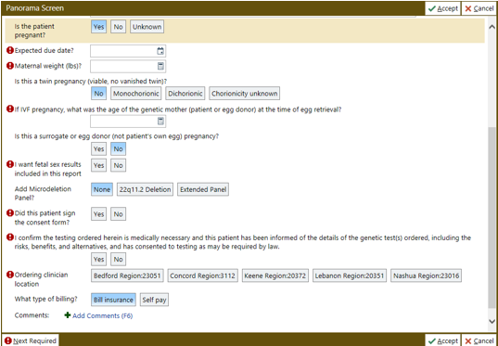

**Labeling/Packaging:**

* All tubes in the kit must be labeled with the Cerner label
* Epic requisition must be sent with each kit.
* Patient Insurance demographics must accompany kit for orders not originating in EPIC. EPIC orders will transmit the patient insurance electronically.

**Reporting of Results**

* Results interfaced back to Laboratory.

For questions concerning this notice, please contact Dr. Mark Cervinski ([Mark.A.Cervinski@hitchcock.org](mailto:Mark.A.Cervinski@hitchcock.org))