Mark A. Cervinski, PhD, DABCC

# Director of Clinical Chemistry

# Associate Professor of Pathology and Laboratory Medicine

## (603) 650-7114

Dartmouth Health Lebanon

PATHOLOGY AND LABORATORY MEDICINE

CLINICAL CHEMISTRY

Date: 7/20/2022

From: Mark A. Cervinski, Ph.D.

Director of Clinical Chemistry

RE: Celiac Serology Testing Cascade, Change in Test Method, Location & Reference Intervals

Please be advised that on Thursday, July 21, 2022, there will be a change in the testing methodology and reference intervals for Tissue Transglutaminase IgG, Deamidated Gliadin IgA, and Deamidated Gliadin IgG antibody tests. The change in methodology is a consequence of the internalization of these tests which will now be performed in the Special Chemistry Laboratory at Dartmouth-Hitchcock Medical Center.

A table summarizing the old and new interpretive criteria is included below.

|  |  |  |
| --- | --- | --- |
| **Test Description** | **New Interpretive Criteria** | **Old Interpretive Criteria** |
| Tissue Transglutaminase IgG | Negative: < 7 U/mL  Indeterminate: 7 – 10 U/mL  Positive: > 10 U/mL | Negative: <6.0 U/mL  Weak positive: 6.0-9.0 U/mL  Positive: >9.0 U/mL |
| Deamidated Gliadin IgA | Negative: < 7 U/mL  Indeterminate: 7 – 10 U/mL  Positive: > 10 U/mL | Negative: <20.0 U  Weak positive: 20.0-30.0 U  Positive: >30.0 U |
| Deamidated Gliadin IgG | Negative: < 7 U/mL  Indeterminate: 7 – 10 U/mL  Positive: > 10 U/mL | Negative: <20.0 U  Weak positive: 20.0-30.0 U  Positive: >30.0 U |

Due to the differences in interpretive criteria, new order codes for the internalized tests have been created in eDH, and the old test names and lab numbers discontinued. Please update your preference lists with the new test orders as listed below.

|  |  |
| --- | --- |
| **New eDH Test Name and LAB Number** | **Inactivated eDH Test Name and LAB Number** |
| TTG IgA, LAB723 = No Change | Not Applicable |
| TTG IgG, LAB4314 | Not Applicable |
| Gliadin IgA, LAB4194 | Gliadin (Deamidated) Antibodies, LAB725 |
| Gliadin IgG, LAB4193 | Gliadin (Deamidated) Antibodies, LAB725 |
| Celiac Cascade, LAB4191 | Celiac Serology Cascade, LAB3815 |

The new DHH Celiac Serology Cascade (LAB4191) is displayed below.

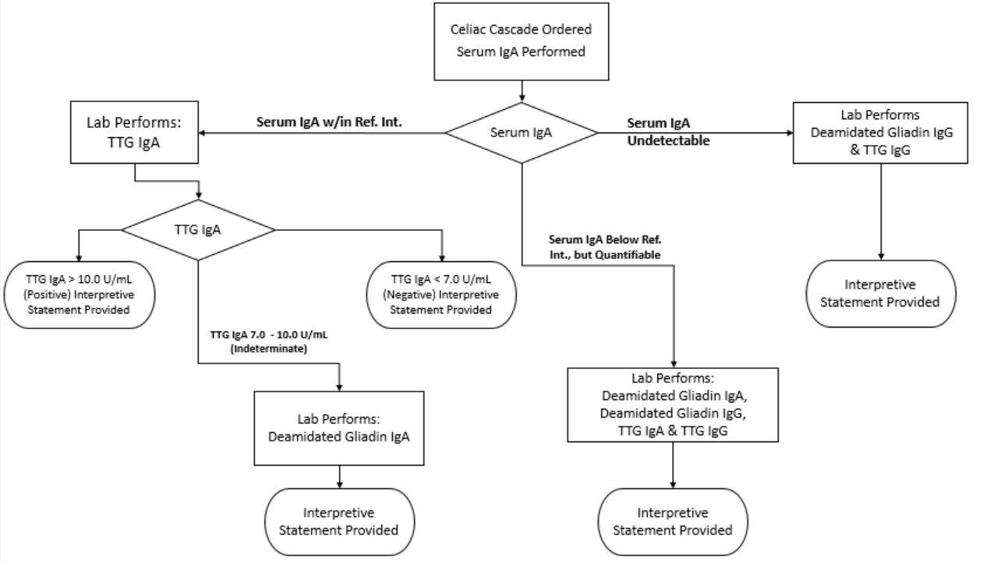

Please contact Dr. Cervinski at [mark.a.cervinski@hitchcock.org](mailto:mark.a.cervinski@hitchcock.org) with any questions pertaining to this notice.