To: Dartmouth Health Providers ordering Clinical Germline Whole Exome Sequencing and hereditary gene panels testing
From: Wahab A. Khan, PhD; Nidhi D. Shah, MD; Mary Beth P. Dinulos, MD; Parth S. Shah, MD;
Joel A. Lefferts, PhD; Gregory J. Tsongalis, PhD
Date: August 17, 2022
RE: Clinical Germline Whole Exome Sequencing and hereditary gene panels
Starting week of 8/15/2022

Germline Exome Test details:

The Center for Applied Genomics and Advanced Technology (CGAT) in the Department of Pathology at DHMC will be offering germline whole exome sequence (gWES) and hereditary gene panel testing for specific conditions beginning the week of 8/15/2022. Please note that this test can ONLY be ordered following a Medical Genetics referral (see test order details below). This test is validated for individuals with complex medical genetic histories or who have had a previous inconclusive genetic test result. Germline WES analyzes the protein-coding regions of ~20,000 genes to identify variants implicated in rare Mendelian disease.

The diagnostic yield of germline exome sequencing ranges from 25% to 50% (PMID: 24088041) in undiagnosed cases. This test will provide an additional opportunity to end diagnostic odysseys in hereditary disease with a positive impact for patients in terms of family planning, care trajectories, and psychological and emotional well-being.

The specific information on each test is provided below. The interpretation of gWES relies significantly on the provided clinical information including relevant clinical notes.

Indications for Testing (broad categories)
- Exhausted genetic testing options
- Patients with a long list of differential diagnoses
- Constellation of phenotypic features suggesting syndromic dysmorphology
- Atypical presentation of disease

Recommendations

If insurance preauthorization is being sought prior to testing and samples are collected prospectively, please be sure to order as a molecular hold in the comments of the specific epic orderable for the appropriate specimen. Please update the order once prior authorization is received so lab specimen receiving in Pathology and the CGAT molecular testing lab can initiate the appropriate work flow on a sample that was previously requested for a molecular hold.

The ‘Mol Path Hold’ option is in place to accommodate patients who would not be easily collected as they may live several hours from an onsite genetics consult or the patient may be a difficult draw and is being collected under sedation.

Turnaround time: Depending on the complexity of the order, prior authorization approvals, and follow up familial testing; results will typically be available within 6-10 weeks for germline exomes. Results for single or custom gene panel testing will have shorter turnaround times depending on the complexity of the panel.

Specimen details:

The preferred specimen is EDTA anticoagulated peripheral whole blood. Buccal swab samples can be accommodated for familial testing (e.g. parents of a proband).

- Blood Collection tube: Purple top tube with EDTA for whole blood
- Buccal Collection tube: ORAcollect (OCR-100) from DNA Genotek Inc.
- Whole blood volume: 3-5 mL (minimum acceptable = 0.5-1 mL)
- Storage (blood and buccal): Ambient temperature for transport within 24 hours to CGAT lab or refrigerated over
weekend

Test ordering details

There are 4 orders for the gWES test, see below. In CERNER, this corresponds to DH MP WES worklist. At present, germline exome sequencing is available by referral or prior consult with Genetics at DH-H.

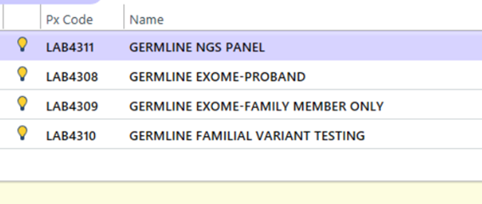
1. LAB4311 NGS gene panel order covers a neurodevelopmental disease (NDD) exome-based panel and a connective tissue disorder (CTD) panel. The gene lists for these panels can be found as a link out pdf in the respective epic orderable and the link will also be present on the final report. Both single gene and custom gene testing with add-on testing to the full NGS germline panel are available. A single gene or custom gene report will be released. Please provide a new order request to the CGAT laboratory if reflex testing is required.

- If a new specimen is to be collected, then the same workflow should be used as the original order.
- If the previously collected specimen is to be used, then the ordering provider must select the “Add on” priority (the default priority when the order is first pulled up is “routine”).
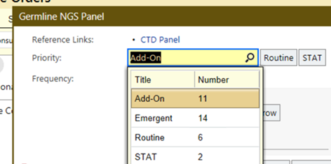

2. LAB4308 Germline proband exome option (i.e. Singleton analysis) can be used if biological parents are not available. Please note in order to maximize interpretation of germline exome orders, testing of biological parental samples is recommended.

3. LAB4309 Exome family member option is to be used when biological parents (i.e. Trio analysis) are requested. This would help guide proband analysis. This lab order is to be filled out so that parents or family members can be tracked and linked to the proband order, LAB4308, and the specific medical record number.

4. LAB4310 currently is being offered for targeted variant testing for parents or siblings for pathogenic, likely pathogenic variants, and variants of uncertain significance. Similar to trio exomes, it is advised that testing of biological parents be performed as part of a trio NGS panel analysis, where possible and clinically warranted, as detailed above.

For additional information, please contact the CGAT lab 603-650-8257 or email CGAT_NGS_Group@hitchcock.org with questions or concerns.

