To: All Dartmouth Health Providers

From: Mark A. Cervinski, PhD, DABCC
Director of Clinical Chemistry and Point-of-Care Testing

Date: February 6, 2023

RE: Allergen Reflex-to-Component Orders Now Available

Effective February 7, providers will have the option to request reflex testing for peanut or hazelnut IgE component panels for patients with positive peanut- or hazelnut-specific IgE results. When ordering peanut or hazelnut IgE, a new order-entry question will appear in the order field in which the provider must indicate their desire for reflex testing (see screenshot below).

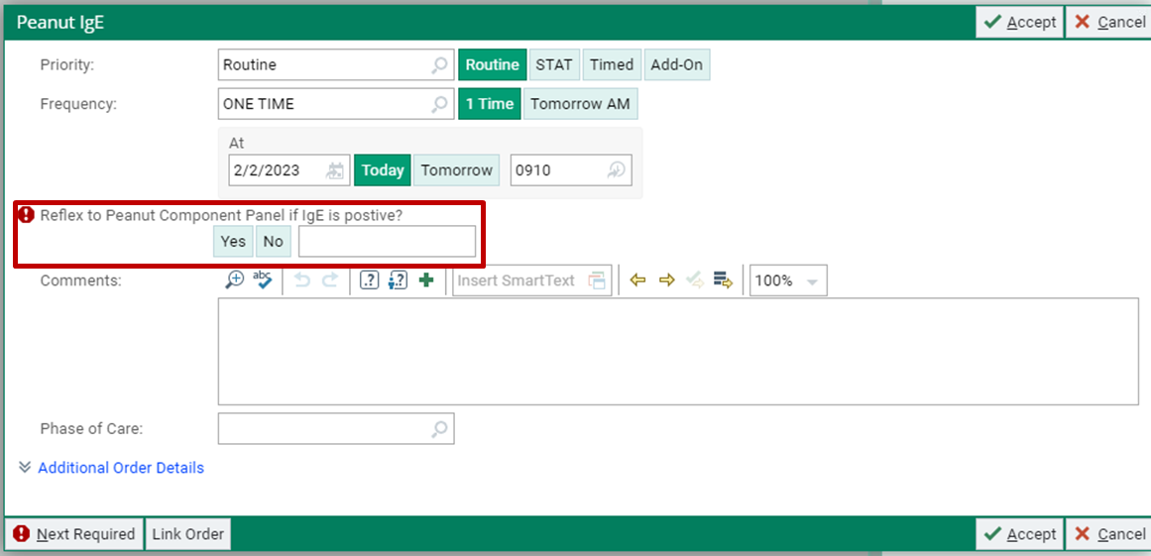

If "Yes" is selected and the peanut- or hazelnut-specific IgE result is 0.35 kU/L or greater, the corresponding component panel will be added on automatically. If "No" is selected, the component panel will not be performed regardless of the specific IgE result.

The peanut and hazelnut component orderable tests will still be available as separate orders, independent of the reflex option.

For questions or additional information, please contact: mark.a.cervinski@hitchcock.org, kimball.a.geno@hitchcock.org, or lynn.a.brunelle@hitchcock.org

Please check off the appropriate distribution lists by clicking the box:

☒ StaffPhysicians-Lebanon@hitchcock.org
☒ StaffPhysicians-Concord@hitchcock.org
☒ StaffPhysicians-Manchester@hitchcock.org
☒ StaffPhysicians-Nashua@hitchcock.org
☒ APRN-Lebanon@hitchcock.org
☒ APRN-Concord@hitchcock.org
☒ APRN-Manchester@hitchcock.org
☒ APRN-Nashua@hitchcock.org
☒ PA-Lebanon@hitchcock.org
☒ PA-Concord@hitchcock.org
☒ PA-Manchester@hitchcock.org
☒ PA-Nashua@hitchcock.org
☒ GME-Residents-Fellows@hitchcock.org

☒ APD: Peter Glenshaw - glenshawp@apdmh.org; and Kelli Pippin- pippink@apdmh.org
☒ Cheshire: Matthew Barone - mbarone@cheshire-med.com; and Heather Atwell - hatwell@cheshire-med.com
☒ New London: Timothy.Lund@newlondonhospital.org; and Kathleen.Kennedy@newlondonhospital.org

