To: Dartmouth Health Providers

From: Lynn A. Brunelle, Ph.D., Assistant Director, Clinical Chemistry Services
Isabella W. Martin, M.D., Director, Medical Microbiology Laboratory

Date: 4/25/2023

RE: Updates to Lyme Modified Two-Tier Testing Algorithm, Serum

Effective May 9, 2023, a new testing platform will be used for Lyme serology, the DiaSorin Liaison instrument which uses chemiluminescent immunoassay (CLIA) methodology. This new test will be performed in the Clinical Chemistry section of the laboratory and will replace the Zeus ELISA methodology currently performed in the Microbiology section.

Testing will still follow the CDC-endorsed modified two-tier testing (MTTT) algorithm which starts with an initial total antibody (combined IgG and IgM) screen which, if positive or equivocal, will reflex to confirmatory IgM and IgG testing. Importantly, the assays used for the initial total antibody screen and the IgG and IgM confirmation tests target different Borrelia-specific antigens, including VlsE, VlsE C6 and OspC.

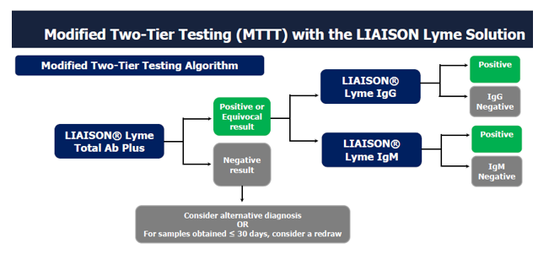
The CDC recommends disregarding IgM test results if the patient has had symptoms for greater than 30 days.

For questions or additional information, please contact:
lynn.a.brunelle@hitchcock.org
isabella.w.martin@hitchcock.org

