TO: Dartmouth Health Providers Ordering IGHV analysis in CLL patients,

FROM: Eric Loo, MD – Assistant Director, CGAT-Molecular Hematology; Samantha Allen, CGAT-Supervisor; Gregory Tsongalis, PhD, CGAT Director

Date: 05/16/2023
Re: Changes in Testing for B- and T-cell clonality for leukemias/lymphomas

The DH Center for Clinical Genomics and Advanced Technology (CGAT) will be providing B- and T-cell gene rearrangement studies by next generation sequencing. Clonality testing will now utilize the Invivoscribe LymphoTrack: IGH FR1/2/3 and TCR B/G assays by next generation sequencing. IGHV testing for CLL with utilize the Invivoscribe LymphoTrack IGHV Leader Somatic Hypermutation assay. The prior method of B- and T-cell receptor assessment by fragment sizing capillary electrophoresis will no longer be performed in-house.

IGHV Somatic Hypermutation analysis for CLL patients will be orderable through eDH. A screenshot of the order in eDH is provided below:

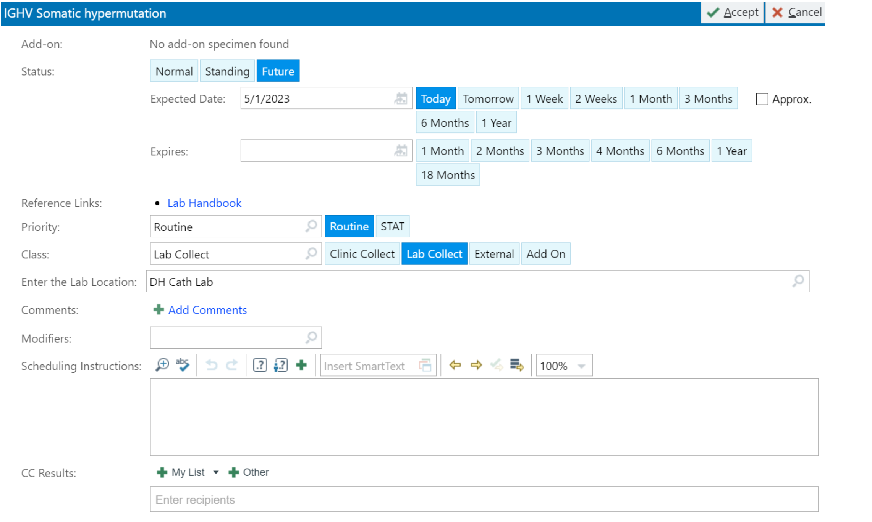

B- and T-cell clonality testing will not be directly orderable in eDH, as it is typically directly ordered by pathology during the course of a lymphoma/leukemia workup.

This switch in testing methodology will eventually permit us to utilize clonal sequences for minimal residual disease (MRD) testing in the near future.

For questions or additional information, please contact: Eric Loo, Samantha Allen or Greg Tsongalis in the Department of Pathology and Laboratory Medicine.

