**To:** All D-HH Providers

**From:** Ella Martin, MD, Medical Director of Microbiology

Nisalda Carreiro, Microbiology Supervisor

**Date:** 10/17/23

**RE:** Fungal Blood Culture Container Change

Effective immediately, the specimen container required for collection of Fungal Blood Cultures [LAB242] has changed.

**Old Container** **New Container**

Isolator Tube Sodium Heparin Tube (4.0 mL)

Discontinued by manufacturer PeopleSoft #0065175

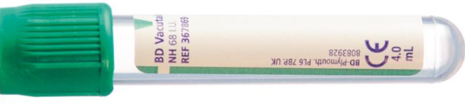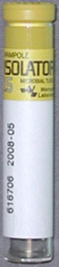

Sodium heparin tubes (4.0 mL) can be obtained by calling the Microbiology Laboratory at 5-2992 or the Client Response Center at 5-2200.

|  |  |  |  |
| --- | --- | --- | --- |
| **Specimen Source** | | **Optimal Volume** | **Minimum Volume** |
| **Blood** | Adult | 4mL | 3mL |
| Pediatric | 3mL | 1mL |
| **Bone Marrow** | All | 3mL | 0.5mL |

Fungal Blood Culture should be ordered only on rare patients suspected of having infection with a thermally dimorphic fungus (e.g. *Histoplasma*) or mold, NOT on patients suspected of candidemia. *Candida* species grow in routine blood cultures.

**For questions or additional information, please contact:**

Ella Martin, MD at [isabella.w.martin@hitchcock.org](mailto:isabella.w.martin@hitchcock.org) or Nisalda Carreiro at [Nisalda.m.carreiro@hitchcock.org](mailto:Nisalda.m.carreiro@hitchcock.org).