**To:** Dartmouth Health providers

**From:** Wahab A. Khan, PhD, FACMG

Gregory J. Tsongalis, PhD, HCLD

Samantha Allen, MB (ASCP), Supervisor

Department of Pathology and Laboratory Medicine - CGAT

**Date:** Nov 27, 2023

**RE:** HLA-B27 PCR Screen for Ankylosing Spondylitis replaces Flow Cytometry based assay

The following lab update addresses a change in test methodology and ordering for HLA-B27 testing. Effective the week of Nov 27, 2023, the CGAT (Clinical Genomics and Advanced Technology) Section of the DPLM will be offering HLA-B27 genotyping on new clinical orders to assess risk for ankylosing spondylitis (AS). This test was previously performed by flow cytometry. The new test will be performed by polymerase chain reaction (PCR) and fluorescence-based melting curve analysis.

This **updated test name is called** ‘**HLA-B27 PCR screen**’. The new **order name in Epic will be** **LAB2180**. Orders can be placed through Epic and results will be provided as ‘DETECTED or ‘NOT DETECTED’ for HLA-B27 alleles associated with AS (specific genotype information is not provided). The result will file under ‘Molecular Pathology’ in Epic (see screen shot below). Specimen collection details are also provided below.

AS is a chronic inflammatory disease that primarily causes pain and inflammation of the joints. HLA-B27 is strongly associated with AS, however the prevalence of positive HLA-B27 and the risk of developing AS is higher among individuals with a positive family history of AS.

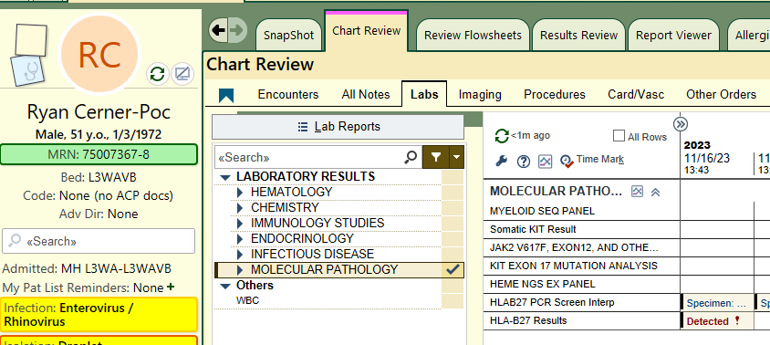

* **Specimen Type:** Whole blood
* **Collection tube:** Lavender top EDTA vacutainer
* **Volume:** 3-5 mL (minimum: 3 mL)
* **Storage/Stability**: Refrigerated @ 4oC for 4 days
* **Transport**: Keep at 4oC; transport within 24-48 hours to the lab
* **Turnaround time**: 3-5 days
* **Epic order name**: LAB2180

**For additional information, please contact the CGAT-Molecular lab 603-650-8257 with questions or concerns.**