**To: Important Changes to Pharmacogenetic Testing to inform prescribing Cancer Chemotherapeutics**

**From:** Wahab A. Khan, PhD, FACMG

Gregory J. Tsongalis, PhD, HCLD

Samantha F. Allen, MB (ASCP), Supervisor

Department of Pathology and Laboratory Medicine – CGAT

**Date:** Feb 19, 2024

**RE:** Pharmacogenomics (PGx) Oncology Panel

**About the test:**

Effective week of Feb 26, 2024, the CGAT (Clinical Genomics and Advanced Technology) Section of the DPLM will be offering expanded Pharmacogenetic(PGx)testing by next generation DNA sequencing (NGS) with a focus towards oncology specificgenotyping for selected gene/drug pairs. CGAT has designed and validated an Oncology PGx Genotyping panel that is intended to help physicians prescribe selected medications that can be influenced by interindividual genetic variability. The panel includes actionable variants in 4 genes (DPYD, TPMT, NUDT15, and UGT1A1). These genes and variants in the clinical PGx panel inform on 7 medications used to treat certain cancers across a series of drugs ranging from fluoropyrimidine, thiopurine analogs, immunosuppressants, and topoisomerase inhibitors.

**Why is this change being made?**

Previously PGx genotyping was being performed for a limited number of SNPs, thus leaving a broader set of Tier 1 and Tier 2 PGx targets recommended by Clinical Pharmacogenetics Implementation Consortium (CPIC) guidelines, FDA drug label recommendations, and peer-reviewed literature unchecked. The current PGx panel by NGS will expand this analysis to cover FDA approved therapeutics in oncology.

**What do Providers need to do?**

Use the order search ‘**PGX ONCOLOGY’ to request the PGx oncology panel** with genes noted above. The new **order in Epic is called** **LAB2153**. The report will be issued for the entire panel and will file under ‘Genetics’ in Epic ‘Chart review’ tab (screenshot below). Please also note that DPYD PCR [LAB4254] and UGT1A1 [LAB3403] orders will be inactivated.

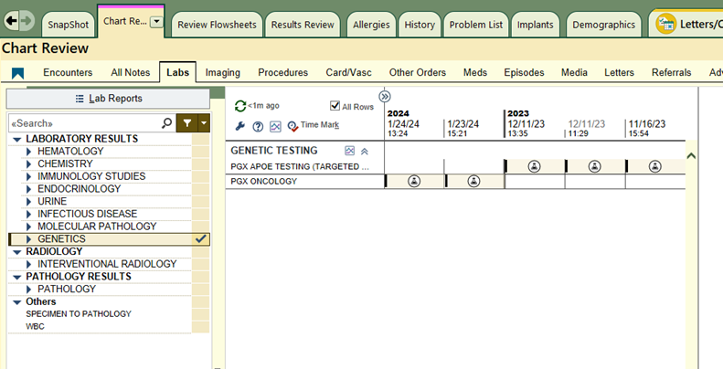

**Specimen Details:**

* **Specimen Type:** Whole blood
* **Collection tube:** Lavender top EDTA vacutainer
* **Volume:** 3mL (minimum 1 mL)
* **Storage/Stability**: Refrigerated @ 4oC for 7 days
* **Transport Temperature**: Keep at 4oC
* **Turnaround time**: 10 days from receipt of specimen. Samples will be batched at least once a week for DNA sequencing (i.e. NGS)
* **Epic order name**: LAB2153

**For additional information, please contact the CGAT-Molecular lab 603-650-8257 or email** [**CGAT_NGS_Group@hitchcock.org**](mailto:CGAT_NGS_Group@hitchcock.org) **with questions or concerns.**