**To:** All D-HH Providers

**From:** Isabella Martin, MD, Medical Director of Microbiology

Nisalda Carreiro, Microbiology Supervisor

**Date:** 05/01/2024

**RE:** Change in Test Method for Group B *Streptococcus* screening

Effective May 7, 2024 the Clinical Microbiology Laboratory at Dartmouth Health will change the testing method used for Group B *Streptococcus* (GBS) screening from vaginal-rectal swabs. We will start using nucleic acid amplification testing following a broth enrichment step. This will be orderable as “Group B Strep by PCR” [LAB4163]. This new test method replaces current culture-based testing for GBS, offering comparable analytical sensitivity.

In patients with penicillin allergy, GBS will automatically be cultured to enable inducible clindamycin testing.

Testing will continue to be performed once daily.

Specimen collection device will remain the same as current:

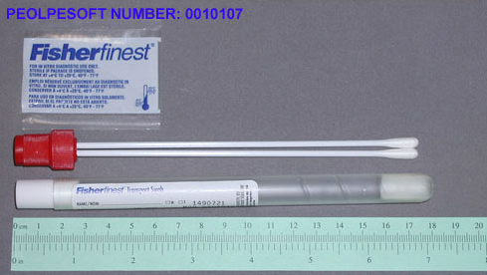

**For questions or additional information, please contact:**

Ella Martin, MD at [isabella.w.martin@hitchcock.org](mailto:isabella.w.martin@hitchcock.org) or Nisalda Carreiro at [Nisalda.m.carreiro@hitchcock.org](mailto:Nisalda.m.carreiro@hitchcock.org).