Date: 5/24/24
From: Isabella Martin, MD, Medical Director of Microbiology
Nisalda Carreiro, Microbiology Supervisor
Rebecca Wang, MD, Co-Director of Comprehensive Antimicrobial Program
To: All D-HH Providers
RE: Implementation of new antimicrobial susceptibility testing panels

Effective Wednesday, May 29th, 2024, the Clinical Microbiology Laboratory will switch to new panels for antimicrobial susceptibility testing (AST) of Gram-negative bacteria on the Vitek2 instrument. This instrument—used in the DHMC laboratory since 2019—automates minimal inhibitory concentration AST of bacteria.

What does this mean for me? You may see slightly different antimicrobial agents listed than you have previously.

Additionally, to optimize antimicrobial stewardship efforts, we will implement cascade reporting, whereby broader spectrum agents are reported only when there is resistance to a narrow spectrum agent within that class. For example, for E. coli, the carbapenems (e.g., meropenem) will be reported only when resistance is detected to ceftriaxone.

The antimicrobial agents present on our new panels are listed in the table below.
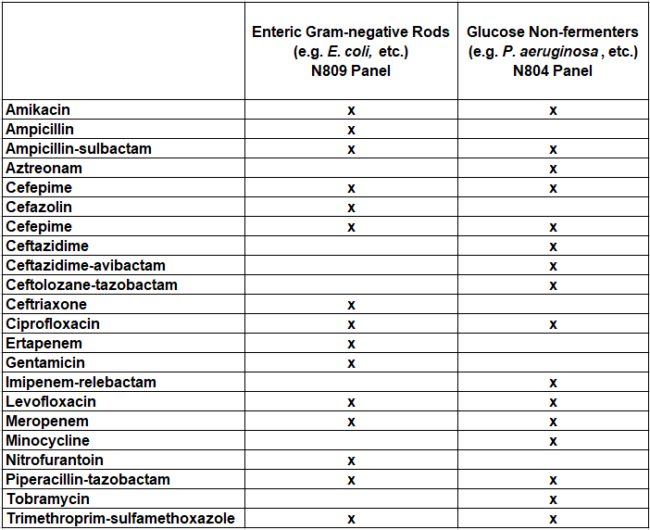
Note: Sometimes antimicrobial agents are suppressed from reporting due to specimen source (e.g. nitrofurantoin reported only on urine specimens), species of bacteria (e.g. intrinsic resistance), or technical issues.

For questions or additional information, please contact: isabella.w.martin@hitchcock.org or nisalda.m.carreiro@hitchcock.org

