**To:** All D-HH Providers

**From:** Ella Martin, MD, Medical Director of Microbiology

Nisalda Carreiro, Microbiology Supervisor

**Date:**  July 1, 2024

**RE:** Blood Culture Bottle Shortage

Aerobic plus Anaerobic lytic Pediatric plus MycoFlytic (Blood AFB)

PS# 0002528 PS# 0002530 PS# 0144168 Request from Micro lab

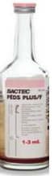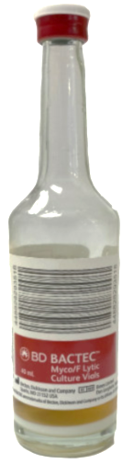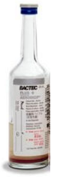

**Situation:**  There is currently a shortage of BD blood culture media that is expected to last through at least September 2024.

**Background:** Blood culture media is on manufacturer allocation. For several months, BD has seen reduced availability of plastic bottles from their supplier that has prevented them from manufacturing BD BACTEC media to fulfill global demand.

**Assessment**: Microbiology and purchasing departments will be closely monitoring supplies on-hand and working with vendor to maintain adequate supplies. There are no alternative vendors to purchase this product from.

**Recommendation:** Until inventory can be stabilized, the following mitigations measures will be in place:

1. Providers must order new blood cultures judiciously. Diagnosing sepsis is critical to patient care, yet clinical need must be evaluated in all patients before ordering blood cultures.
2. **Standing blood culture orders should be discontinued and reviewed for necessity.**
   1. In patients with a confirmed bloodstream infection, follow-up blood cultures are NOT needed daily to confirm clearance of the bloodstream infection. These should typically be done not more frequently than every 2 days.
   2. Indications for follow-up blood cultures include:
      1. Bloodstream infection due to *Staphylococcus aureus* or *Staphylococcus lugdunensis*
      2. Concern for or confirmation of an endovascular infection (e.g., endocarditis, pacemaker infection, intravascular catheter infection, vascular graft infection, septic thrombophlebitis)
      3. Presence of fever, elevated white blood cell count, or other signs of infection for more than 72 hours after starting antibiotics
      4. Known or suspected abscess or joint space infection
      5. Presumed source of infection in the abdomen or central nervous system
      6. Multi-drug resistant bacteria
3. We’ll provide updated information on this situation as further developments unfold.

**For questions or additional information, please contact:**

Ella Martin, MD 603-650-7171

Nisalda Carreiro 603-650-4851