**TO:** Dartmouth Hitchcock Medical Center and Community Group Practice Providers

**FROM:** Nicole Loeven, PhD, D(ABMM), Assistant Medical Director of Microbiology

Ella Martin, MD, Medical Director of Microbiology

Nisalda Carreiro, BS, MT (ASCP), Microbiology Supervisor

Michael S. Calderwood, MD, MPH, DHMC Chief Quality Officer

**Date:** January 13, 2025

**Re:** Best Practices for Respiratory Virus Testing

**Situation**

We are now deeply into “respiratory virus season” when Influenza A/B and Respiratory Syncytial Virus (RSV) spread more widely, leading to an increase in respiratory illnesses each year. The following guidance describes appropriate diagnostic testing in different patient populations.

**Background**

In recent weeks the number of positive PCR results for Influenza A [has risen](https://one-dh.testcatalog.org/show/Micro-2). These local data align with national trends and are consistent with the positivity rates typically observed at this time of year.

**Assessment**

Following evidence-based testing recommendations ensures optimal patient care.

**Recommendation**

Per CDC guidance, testing for influenza should be limited to patients with influenza-like illness (ILI) who require hospital admission and for those select outpatients for whom test results will change patient management or for infection control reasons (e.g., residents of rehabilitation facilities and nursing homes).

Testing for influenza infection and other non-COVID respiratory viruses in otherwise healthy outpatients with ILI is not recommended.

The DHMC laboratory can test for SARS-CoV-2 and Influenza/RSV with a single NP swab.

The “Respiratory Panel by PCR” which tests for an expanded spectrum of possible respiratory pathogens should be ordered only on immunocompromised and/or critically ill inpatients and those being admitted from the Emergency Department. This test should not be ordered on outpatients.

Testing guidance for appropriate patients is outlined in the figure below.

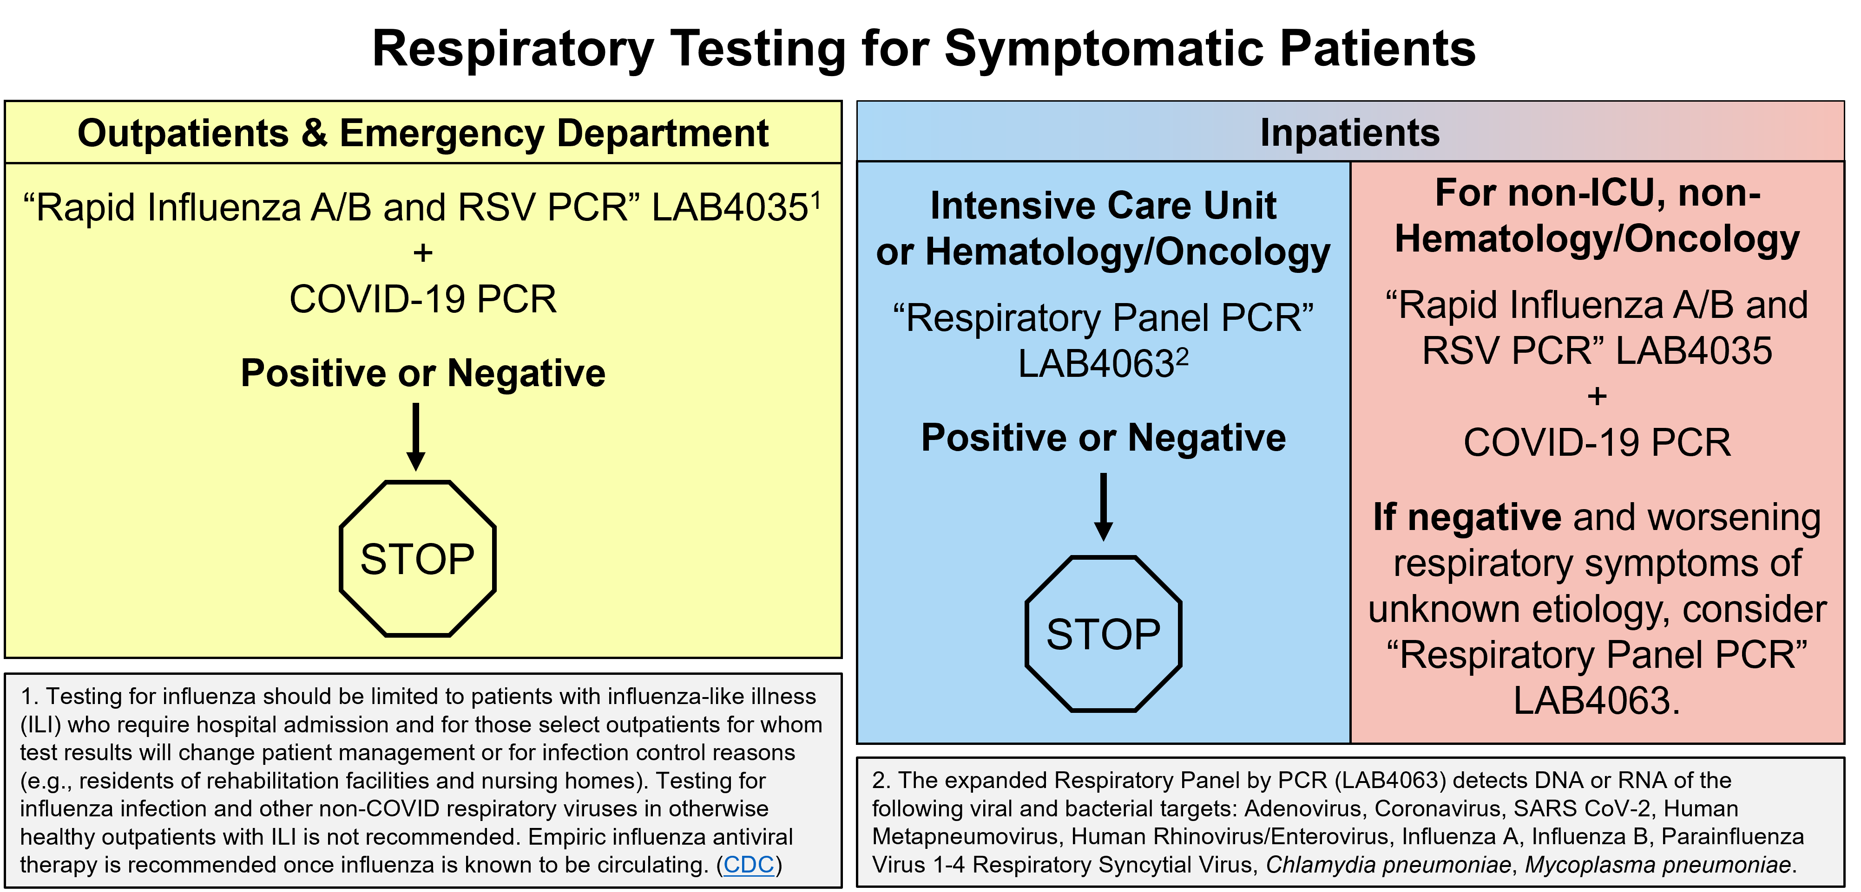

Highly Pathogenic Avian Influenza (HPAI)

Aside from circulation of the “usual” subtypes of Influenza A, there have been human cases of HPAI, commonly called “bird flu”, most of which are related to exposure to infected animals (e.g., wild birds, commercially raised poultry, and cattle) in the United States. There have been no reported cases of HPAI in humans in New England.

The “Respiratory Panel by PCR” should be ordered for patients with suspected HPAI and the Microbiology Director on-call should be notified. HPAI would be detected as Influenza A without further subtyping. The DHMC Microbiology Laboratory would then send the specimen to the New Hampshire Public Health Laboratory for typing. Preliminary positive results would trigger an appropriate public health response and confirmatory testing would be performed by the Centers for Disease Control and Prevention.

**For questions or additional information, please contact:**

Nicole Loeven, PhD, D(ABMM), [Nicole.A.Loeven@hitchcock.org](mailto:Nicole.A.Loeven@hitchcock.org), (603) 650-7171

Ella Martin, MD, D(ABMM), [Isabella.W.Martin@hitchcock.org](mailto:Isabella.W.Martin@hitchcock.org), (603) 650-7171

Nisalda Carreiro, BS, MT (ASCP) [Nisalda.M.Carreiro@hitchcock.org](mailto:Nisalda.M.Carreiro@hitchcock.org), (603) 650-7171