**TO:** All D-HH Providers

**FROM:** Isabella Martin, MD, Medical Director of Microbiology

Nicole Loeven, PhD, Assistant Director of Microbiology

Nisalda Carreiro, Microbiology Supervisor

**Date:** 3/14/2025

**Re:** Measles Testing Guidance

In light of the recent spike in measles cases in the United States, we are working to create orderable tests in EPIC for both Measles PCR and Measles IgM. Until that work is complete, ordering testing for measles can be accomplished as follows:

**Measles PCR is the best test to order to diagnose acute illness.** Order test as a "Miscellaneous Lab" with “measles PCR” in the comment field. Collect a nasopharyngeal swab (pictured below). An oropharyngeal specimen is an alternative option. We will send samples to the New Hampshire Public Health Laboratory once daily Monday-Friday.

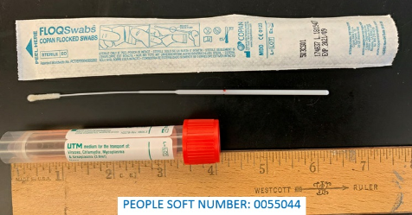

Individual flocked swabs (People Soft 0125980) and Universal Transport Media (UTM, People Soft 0136130) can alternatively be obtained and used together.

**Measles** **IgM antibody testing can also be helpful.** Order test as a "Miscellaneous Lab" with “measles IgM” in the comment field.  Collect serum (red top) tube. We will send samples to a commercial reference laboratory (Mayo Medical Laboratories) for testing. Specimens sent once daily Monday-Friday.

**For questions or additional information, please contact:** (603)650-7171,[isabella.w.martin@hitchcock.org](mailto:isabella.w.martin@hitchcock.org) [nicole.a.loeven@hitchcock.org](mailto:nicole.a.loeven@hitchcock.org) or [nisalda.m.carreiro@hitchcock.org](mailto:nisalda.m.carreiro@hitchcock.org)