**TO:** Dartmouth Hitchcock Medical Center and Community Group Practice Providers

**FROM:** Nicole Loeven, PhD, D(ABMM), Assistant Medical Director of Microbiology

Isabella Martin, MD, D(ABMM), Medical Director of Microbiology

Nisalda Carreiro, BS, MT (ASCP), Microbiology Supervisor

**Date:** May 12, 2025

**Re:** Measles PCR and IgM Now Orderable Tests in Epic

In response to the recent surge in measles cases across the U.S., Measles PCR and Measles IgM are now orderable tests in Epic.

**Measles PCR is the best test to order to diagnose acute illness.** It is now orderable as “Measles PCR (LAB 2683)”. Collect a nasopharyngeal swab (pictured below). An oropharyngeal specimen is an alternative option. Samples will be sent to the New Hampshire Public Health Laboratory once daily Monday-Friday.

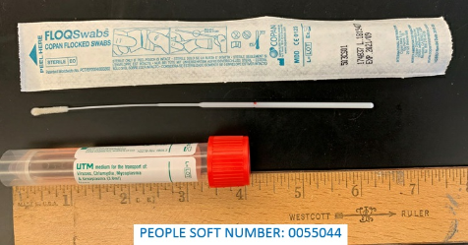

Individual flocked swabs (People Soft 0125980) and Universal Transport Media (UTM, People Soft 0136130) can alternatively be obtained and used together.

**Measles IgM antibody testing can also be helpful. This is now orderable as** “**Measles (Rubeola) Antibody, IgM Mayo (LAB2697)”.** Collect serum (red top) tube. Samples will be sent to a commercial reference laboratory (Mayo Clinic Laboratories) for testing once daily Monday-Friday.

**For questions or additional information, please contact:**

(603) 650-7171, [Nicole.A.Loeven@hitchcock.org](mailto:Nicole.A.Loeven@hitchcock.org), [Isabella.W.Martin@hitchcock.org](mailto:Isabella.W.Martin@hitchcock.org),

[Nisalda.M.Carreiro@hitchcock.org](mailto:Nisalda.M.Carreiro@hitchcock.org)