**To:** Dartmouth Health Providers

**From:** Abigail Johnston, MS, MLS(ASCP)CM

**Date:** July 7, 2025

**Re:** Updated Reflex Criteria for Culture from Urinalysis

Effective July 8, 2025 the criteria used to trigger a culture from the order Urinalysis with Reflex Culture [LAB348] have been updated to improve the negative predictive value and align with best practices.

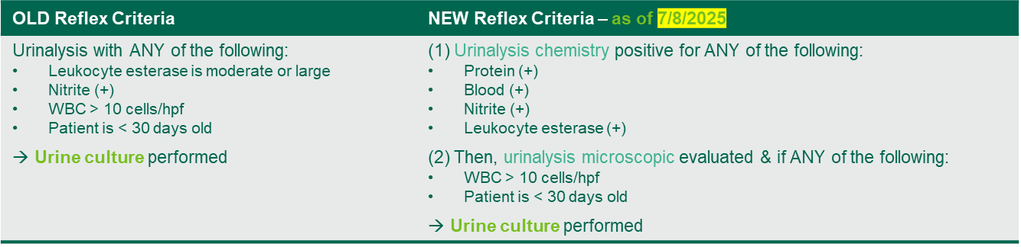

LAB348 should be reserved for patients with signs and/or symptoms of a urinary tract infection (UTI).

Patients who are pregnant, neutropenic, or undergoing urological procedures should have Urine Culture [LAB239] and/or Urinalysis with Microscopic [LAB4024] ordered as separate labs, if desired to guide clinical management.

**What do Providers need to do?**

There is no change to ordering or interpreting these tests. Please reach out for additional information if needed.

**For questions or additional information, please contact:**

Laboratory Medicine Operations Manager, Abigail Johnston, [Abigail.A.Johnston@hitchcock.org](mailto:Abigail.A.Johnston@hitchcock.org)

Hematology Medical Director, Dr. Prabhjot Kaur, 603-650-7225