**To:** Dartmouth Health Providers and Nurses

**From:** Nancy M. Dunbar, MD, Blood Bank and Special Coagulation Medical Director

Brittany E. Condict, MLS(ASCP)CMSBBCM, Transfusion Medicine Service Manager

Rachael M. Chandler, MLT(ASCP)CMBBCM, Blood Bank Supervisor

**Date:** July 23, 2025

**Re:** ABORh Recheck Per Protocol Orders

**Background:** Per regulatory requirements, patients must have two ABORh types in file for transfusion. The ABORh Recheck order is reflexively placed when a Type & Screen is received on a patient with no prior ABORh history. Limitations of Epic prevent access to ABORh Recheck orders reflexed from outpatient/ambulatory encounters when the patient is currently admitted under an inpatient encounter.

**Update:** Effective July 28, 2025, an “Our Practice Advisory” (OPA) will be presented to physicians and nurses when accessing an admitted patient with a pending ABORh Recheck order from a previous ambulatory visit. This will allow a new ABORh Recheck order to be placed and collected for the inpatient visit. The current process of calling the Blood Bank to request that they manually place a new order will no longer be required.

***Note:*** The ABORh Recheck order is unavailable outside of the OPA to all staff external to the Blood Bank laboratory.

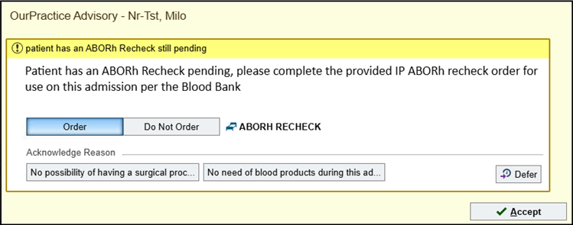

**For questions or additional information, please contact:**

[Nancy.M.Dunbar@hitchcock.org](mailto:Nancy.M.Dunbar@hitchcock.org) ,[Brittany.E.Condict@hitchcock.org](mailto:Brittany.E.Condict@hitchcock.org),or[Rachael.M.Chandler@hitchcock.org](mailto:Rachael.M.Chandler@hitchcock.org)