**To: Dartmouth Health Providers**

**From:** Nancy M. Dunbar, MD, Blood Bank Medical Director

Brittany E. Condict, MLS(ASCP)CMSBBCM, Transfusion Medicine Service Manager

Rachael M. Chandler, MLT(ASCP)CMBBCM, Blood Bank Supervisor

**Date:** September 23, 2025

**Re:        New Test - Prenatal Partner Antigen Type**

The Blood Bank in the Department of Pathology and Laboratory Medicine at DHMC will be offering the Prenatal Partner Antigen Type test order, beginning 9/25/2025. The test order is to be used for requesting red blood cell antigen typing of the partner of prenatal patients with known red blood cell antibodies in order to determine the likelihood that the partner will pass on the expression of the antigen to the baby. In order to submit the order, the mother of the baby information must be entered.

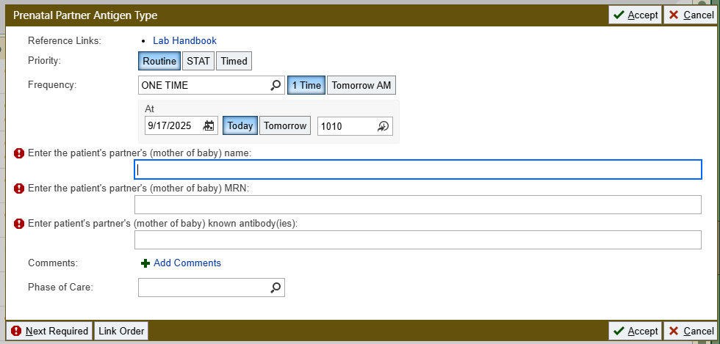

**Specimen details:** The preferred specimen is EDTA anticoagulated peripheral whole blood.

**Test ordering details:** LAB2162

**For questions or additional information, please contact:**

[Nancy.M.Dunbar@hitchcock.org](mailto:Nancy.M.Dunbar@hitchcock.org) ,[Brittany.E.Condict@hitchcock.org](mailto:Brittany.E.Condict@hitchcock.org),or[Rachael.M.Chandler@hitchcock.org](mailto:Rachael.M.Chandler@hitchcock.org)

**Please check off the appropriate distribution lists by clicking the box:**

[StaffPhysicians-Lebanon@hitchcock.org](mailto:StaffPhysicians-Lebanon@hitchcock.org)

[StaffPhysicians-Concord@hitchcock.org](mailto:StaffPhysicians-Concord@hitchcock.org)

[StaffPhysicians-Manchester@hitchcock.org](mailto:StaffPhysicians-Manchester@hitchcock.org)

[StaffPhysicians-Nashua@hitchcock.org](mailto:StaffPhysicians-Nashua@hitchcock.org)

[APRN-Lebanon@hitchcock.org](mailto:APRN-Lebanon@hitchcock.org)

[APRN-Concord@hitchcock.org](mailto:APRN-Concord@hitchcock.org)

[APRN-Manchester@hitchcock.org](mailto:APRN-Manchester@hitchcock.org)

[APRN-Nashua@hitchcock.org](mailto:APRN-Nashua@hitchcock.org)

[PA-Lebanon@hitchcock.org](mailto:PA-Lebanon@hitchcock.org)

[PA-Concord@hitchcock.org](mailto:PA-Concord@hitchcock.org)

[PA-Manchester@hitchcock.org](mailto:PA-Manchester@hitchcock.org)

[PA-Nashua@hitchcock.org](mailto:PA-Nashua@hitchcock.org)

[GME-Residents-Fellows@hitchcock.org](mailto:GME-Residents-Fellows@hitchcock.org)

[Nursing-Lebanon@hitchcock.org](mailto:Nursing-Lebanon@hitchcock.org)

[Nursing-Concord@hitchcock.org](mailto:Nursing-Concord@hitchcock.org)

[Nursing-Manchester@hitchcock.org](mailto:Nursing-Manchester@hitchcock.org)

[Nursing-Nashua@hitchcock.org](mailto:Nursing-Nashua@hitchcock.org)

**APD:** Carole Gaudet [gaudetc@apdmh.org](mailto:gaudetc@apdmh.org); Amy Cadorette [cadorettea@apdmh.org](mailto:cadorettea@apdmh.org); and Brooke Maddock [maddockb@apdmh.org](mailto:maddockb@apdmh.org)

**Cheshire:** Matthew Barone – [mbarone@cheshire-med.com](mailto:mbarone@cheshire-med.com); and

Heather Atwell – [hatwell@cheshire-med.com](mailto:hatwell@cheshire-med.com)

**New London:** Kathleen Kennedy [Kathleen.Kennedy@newlondonhospital.org](mailto:Kathleen.Kennedy@newlondonhospital.org); and Julia Whitney [julia.whitney@newlondonhospital.org](mailto:julia.whitney@newlondonhospital.org)