

To: Dartmouth Health providers: Important Update to Cardiology Pharmacogenetic Panel for
Antiplatelet and Statin Management

From: Wahab A. Khan, PhD, – CGAT Associate Director/Director, Molecular Genetics and Cytogenetics
Parth Shah, MD, – CGAT Associate Director/Director, Genomic Informatics
Laura J. Tafe, MD – CGAT Medical Director/Director, Molecular Oncology
Samantha F. Allen, MB (ASCP) – CGAT Supervisor, Molecular Pathology
Department of Pathology and Laboratory Medicine

Date: Oct 29, 2025
RE: Pharmacogenomics (PGx) Cardiology Panel

About the test:
Effective week of Oct 27, 2025, the CGAT (Clinical Genomics and Advanced Technology) Section of the DPLM will be offering expanded Pharmacogenetic (PGx) testing by next generation DNA sequencing (NGS) with a focus towards cardiovascular specific genotyping for select gene/drug pairs. The CGAT molecular pathology laboratory has designed and validated a Cardiology PGx Genotyping panel that is intended to help physicians prescribe selected medications that can be influenced by interindividual genetic variability. At time of release of this lab update, the panel includes actionable variants in 4 genes (CYP2C19, CYP2C9, ABCG2, SLCO1B1). These genes and their genetic variants in drug-metabolizing enzymes inform on 8 medications on the current panel (Clopidogrel, Rosuvastatin, Fluvastatin, Simvastatin, Atorvastatin, Lovastatin, Pitavastatin, Pravastatin), including antiplatelet therapy effectiveness and statin-associated adverse events.

Why is this change being made?
Previously PGx genotyping was being performed for a limited number of SNPs, thus leaving a broader set of Tier 1 and Tier 2 PGx targets recommended by Clinical Pharmacogenetics Implementation Consortium (CPIC) guidelines, FDA drug label recommendations, and peer-reviewed literature unchecked. The current PGx Cardiology panel by NGS will expand this analysis to cover therapeutics in cardiovascular medicine, noted above.

What do Providers need to do?
Use the order search ‘PGX Cardiology’ in epic procedure catalog ‘search field’ or epic order code LAB2154 to request this PGx panel (see screenshots below for ordering steps). The report will be issued for the entire panel and will file under ‘Genetics’ in Epic ‘Chart review’ tab as a pdf. Please also note that CYP2C19 Genotyping test order [LAB4323] will be inactivated from epic preference lists. Testing using the PGx Cardiology panel will replace the CYP2C19 genotyping order.

Steps to Order PGx Cardiology Panel

Search for Pharmacogenomics Cardiology. Select LAB2154 parent panel
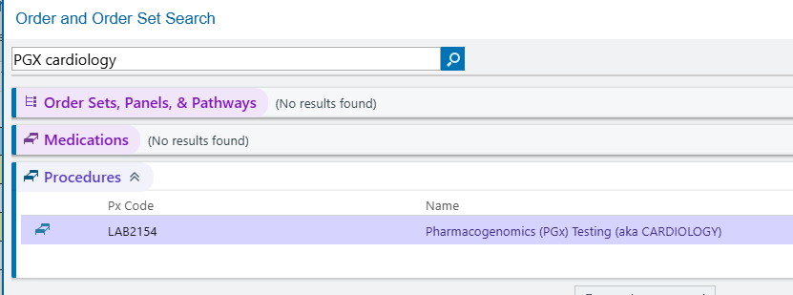

Select the PGx Cardiology panel in the parent order under ‘Type of PGx testing requested’ as indicated below
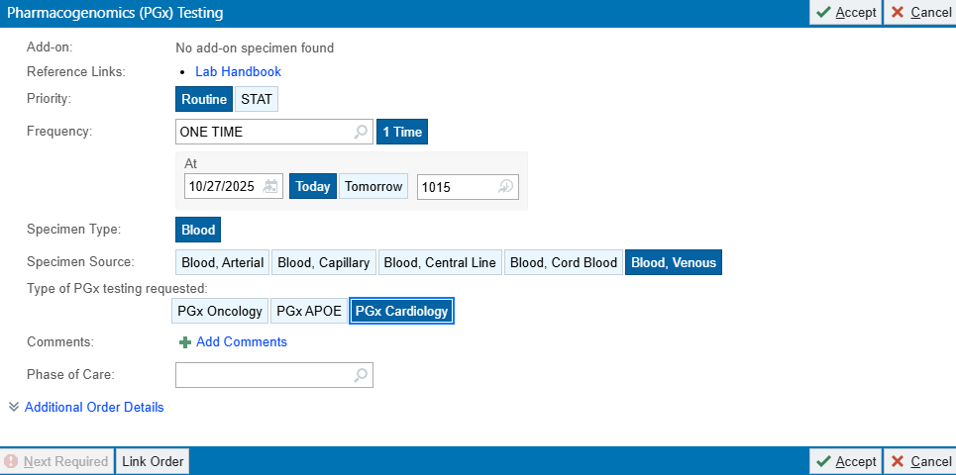

Once results are released, they will file under Genetics Result tab in Epic

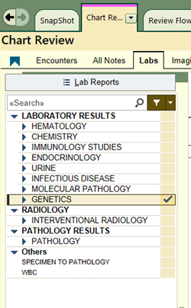

Specimen Details:
- Specimen Type: Whole blood
- Collection tube: Lavender top EDTA vacutainer
- Volume: 3mL (minimum 1 mL)
- Storage/Stability: Refrigerated @ 4ºC for 7 days
- Transport Temperature: Keep at 4ºC
- Turnaround time: 10 days from receipt of specimen. Samples will be batched at least once a week for DNA sequencing (i.e. NGS)
- Epic order code: LAB2154
For additional information, please contact the CGAT-Molecular lab 603-650-8257 or email CGAT_NGS_Group@hitchcock.org with questions or concerns.

