TO: Dartmouth Hitchcock Medical Center and Community Group Practice Providers

FROM: Nicole Loeven, PhD, D(ABMM), Assistant Medical Director of Microbiology

Isabella Martin, MD, D(ABMM), Medical Director of Microbiology

Nisalda Carreiro, BS, MT (ASCP), Microbiology Supervisor

Date: November 9, 2025

Re: New Look in eDH: Rapid Blood Culture Identification and Blood Culture

Situation
Recently, the DH Antimicrobial Stewardship Program has identified several instances when genetic markers of antimicrobial resistance have been detected and reported on a blood culture, but missed on the front-line clinician end due to lack of visibility in eDH. Starting Tuesday November 11, 2025, the appearance of positive blood culture results will be updated in eDH system-wide. The new layout will include a separate line in Results Review for the BioFire Blood Culture ID (BCID2) multiplex PCR test result, which will be right below the Blood Culture result. The appearance of results of the Blood Culture will not change.

Background
The BCID2 (and its predecessor) is a molecular test that has been used for positive blood cultures at the DHMC Microbiology Laboratory for 10 years. The BCID2 detects the presence of the most common organisms that cause bloodstream infection, as well as key genetic determinants of antimicrobial resistance (e.g., mecA/C, vanA/B, CTX-M, etc.). A full list of targets on the BCID2 panel can be found here. This test typically results at the time that a positive Gram stain is reported, then full culture and susceptibility results generally result ~24 hours later.

The BCID2 test is performed automatically on all initial positive blood cultures. There are no changes being made to the criteria for which this test is run.

Changes are being made to the result display to increase the visibility of genetic determinants of antimicrobial resistance, when detected. In addition, there will be accompanying guidance for empiric antimicrobial selection and/or and Infectious Disease consultation.

Examples of this new look are included below.

Appearance when hovering over the Blood Culture ID PCR result:

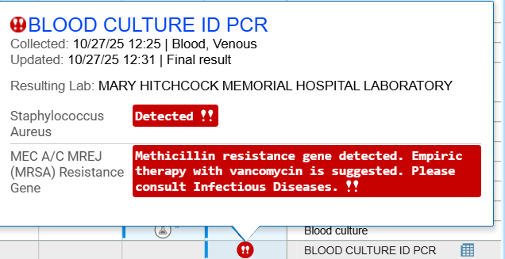

If an organism growing in a blood culture is not a target of the BCID2 panel this will result as “Negative”, as below:

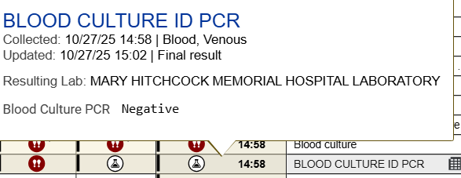

Results will also appear in the 30-Day Micro Summary view and will include all associated comments. Please note, the example below represents a single blood specimen where the NEW, more detailed “BLOOD CULTURE ID PCR” result is added directly below the corresponding “Blood culture” result:

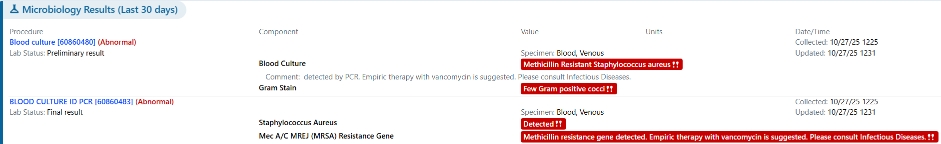

The results of the initial Gram stain, as well as the final culture and susceptibility result, will appear in the Blood Culture field. This is not a change from prior reporting strategy.

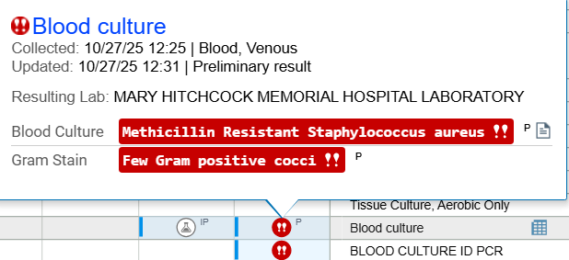

Assessment
This new look should make BCID2 results easier to find, improving the optimization of antimicrobial therapy at our institution.

Recommendation
Please review all parts of the BCID2 result and any associated comments when reviewing a positive blood culture as these are essential for initiating proper empiric therapy for a bloodstream infection.

As a reminder, detailed guidance from the DH Antimicrobial Stewardship Program is available to assist in selection of empiric therapy for patients with a positive blood culture result. It can be found here: Blood Culture (BCID2) Therapy Guidance.

For questions or additional information, please contact:
Nicole Loeven, PhD, D(ABMM), Nicole.A.Loeven@hitchcock.org, (603) 650-7171
Isabella Martin, MD, Isabella.A.Martin@hitchcock.edu, (603) 650-7171
Nisalda Carreiro, BS, MT (ASCP) Nisalda.M.Carreiro@hitchcock.org, (603) 650-4851

For DH Antimicrobial Stewardship questions, please contact:
Rebecca Wang, MD, Rebecca.Wang@hitchcock.org, (603) 650-8440
Julie Ann Justo, PharmD, MS, FIDSA, BCPS, Julie.Ann.Justo@hitchcock.org, (603) 650-5668
Craig Worby, PharmD, BCIDP, BCCCP, BCPS, Craig.P.Worby@hitchcock.org, (603) 650-7675

