To: Dartmouth Health providers

From: Wahab A. Khan, PhD, – CGAT Associate Director/Director, Cytogenetic/Molecular Genetics

Laura J. Tafe, MD – CGAT Medical Director/Director, Molecular Oncology

Lauren M. Wainman, PhD, Cytogenetics Supervisor

Department of Pathology and Laboratory Medicine

Date: December 8, 2025

Re: Acute Lymphoblastic Leukemia (T-ALL, B-ALL) work up with Digital Karyotyping using Optical Genome Mapping

What is changing?
Effective immediately, the DH Clinical Cytogenetics Laboratory, under the Laboratory for Clinical Genomics and Advanced Technology (CGAT), provides in-house Digital Karyotyping using optical genome mapping (OGM) on Acute Lymphoblastic Leukemia (ALL) cases (T-ALL, B-ALL) as well as certain circulating mature T-cell malignancies (T-prolymphocytic leukemia) referred to Cytogenetics.
OGM is a DNA mapping technology that uses fluorescent signals to resolve high-resolution genomic structures both at the chromosomal and gene level (https://www.cap.org/member-resources/articles/optical-genome-mapping-a-tool-with-significant-potential-from-discovery-to-diagnostics ). Final reports will file under the Cytogenetics section – Digital Karyotyping in Epic.

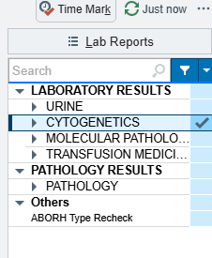

Why are we making this change?
OGM Digital Karyotyping will allow expansion of testing for ALL cases to the set of NCCN/WHO‑recognized ALL‑associated structural lesions, including relatively recent entities such as DUX4‑rearranged, MEF2D‑rearranged, ZNF384‑rearranged, PAX5‑altered, and Ph‑like ALL, while simultaneously surveying pan‑hematologic chromosomal abnormalities that complements standard cytogenetic and genomic workflows.

For questions or additional information, please contact:

LABCYTOGEN@hitchcock.org and/or our hemopathology team, Drs. Prabhjot Kaur, Jeremiah Karrs, and Liam Donnelly

