TO: Dartmouth Hitchcock Medical Center and Community Group Practice Providers

FROM: Nicole Loeven, PhD, D(ABMM), Assistant Medical Director of Microbiology

Isabella Martin, MD, D(ABMM), Medical Director of Microbiology

Nisalda Carreiro, BS, MT (ASCP), Microbiology Supervisor

Date: February 4, 2025

Re: Patient-Collected Vaginal Swab Specimens Now Acceptable for Select Tests

Situation:
Patient-collected vaginal swab specimens collected in clinic in Aptima Multitest collection containers are now acceptable for testing by the DHMC Microbiology Laboratory for the following tests:

- GC/Chlamydia Gene Amplification
- GC Gene Amplification
- Chlamydia Gene Amplification
- Trichomonas Gene Amplification
- Vaginitis/Vaginosis PCR Panel

Background
In an effort to provide an additional, convenient option for vaginal specimen collection, the DHMC Microbiology Laboratory performed a study to assess the performance of patient-collected vaginal swab specimens. Tests assessed in this study included those used for detection of pathogens that cause sexually transmitted infections (Neisseria gonorrhoeae, Chlamydia trachomatis, and Trichomonas vaginalis) and targets on the Vaginitis/Vaginosis PCR Panel (Candida spp., Candida glabrata, Trichomonas vaginalis, and bacterial causes of vaginosis).

Assessment
The DHMC Microbiology Laboratory’s study of patient-collected vaginal swab demonstrated acceptable performance for the above tests and can be used for testing.

Recommendation
- Specimens must be collected in clinic with guidance from a provider and transported to the Microbiology Laboratory at DHMC by normal courier.
  - Aptima Multitest swab collection containers are the only acceptable containers for vaginal specimens. See image below.
  - Collection guidance can be found here
- Patient-collect specimens should never be collected at home.
- No changes have been made to the test ordering process.
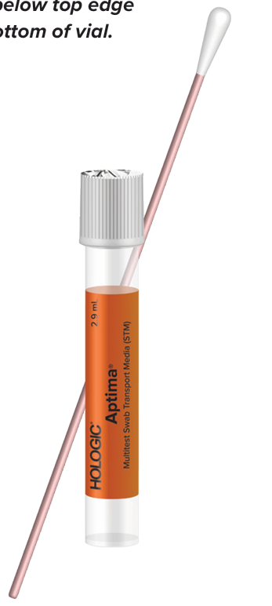

PS# 0133494

For questions or additional information, please contact:
Nicole Loeven, PhD, D(ABMM), Nicole.A.Loeven@hitchcock.org, (603) 650-7171
Isabella Martin, MD, Isabella.A.Martin@hitchcock.edu, (603) 650-7171
Nisalda Carreiro, BS, MT (ASCP) Nisalda.M.Carreiro@hitchcock.org, (603) 650-4851

