To: All DHH Providers

From: Mark A. Cervinski, PhD, DABCC, Medical Director of Chemistry

Sarah E. Labore, MLS(ASCP)^{CM}, Chemistry and Night Shift Supervisor

Date: 2/6/2026

Re: Updated Hepatitis B Surface Antigen Reporting

Please be aware that the laboratory has made a change to the reporting of Hepatitis B surface antigen results. With this change, the Hepatitis B surface antigen results will be split into separate “screen” and “confirmation” components in the results review tree of eDH (see image below).

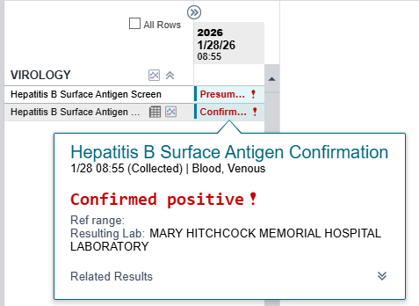

The addition of separate components will facilitate timely reporting of presumptive positive results for those cases in which the confirmation testing is in process but has not yet been completed. Prior to this change, presumptive positive samples were held pending the result of the confirmatory test.

The order code and specimen requirements for the test have not changed, and no action on the part of the ordering provider is needed.

For questions or additional information, please contact:
Mark.a.cervinski@hitchcock.org

