TO: All D-HH Providers

FROM: Isabella Martin, MD, Medical Director of Microbiology
Nicole Loeven, PhD, Assistant Director of Microbiology
Nisalda Carreiro, Microbiology Supervisor

Date: 4/06/2026

Re: Ova & Parasites Examination: Significant Changes to Order Entry Workflow

Effective immediately, the following changes are in effect when placing an order for Ova & Parasites (O&P) Examination [LAB955] in EPIC:

Updated process instructions will appear within the order entry workflow.

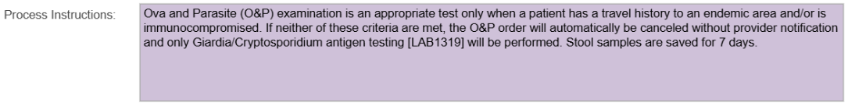

In accordance with evidence-based diagnostic stewardship, orders for O&P will be canceled in patients who:

- lack significant travel history
- are immunocompetent
- have been inpatients for > 3 days
Notification of this cancellation will no longer be communicated by telephone. Instead, an automated cancellation message similar to the Process Instructions above will appear.

If not already ordered, Giardia and Cryptosporidium antigen testing [LAB1319] will be automatically added to all specimens from patients who do not meet criteria for O&P.

Giardia and Cryptosporidium antigen tests are the most sensitive diagnostic method available for the most common stool parasites encountered in the United States.

See Parasitic Investigation of Stool Specimen Algorithm for full guidance on diagnostic testing of stool for parasitic infection.

Specimens are saved in the laboratory for 7 days.

For questions or additional information, please contact: (603)650-7171, isabella.w.martin@hitchcock.org nicole.a.loeven@hitchcock.org or nisalda.m.carreiro@hitchcock.org

