To: All Dartmouth Health Providers

From: Carol (Xiaoying) Liu, Joel Lefferts, Megan Boivin, Samantha Allen

Date: May 20, 2026

Re: Introduction of Primary HPV Testing Option

SITUATION Effective June 1, 2026, Dartmouth Health is introducing Primary HPV testing as a new option for cervical cancer screening (clinician-collected specimen only).

BACKGROUND Based on clinical studies and the availability of HPV tests approved by the FDA for use in Primary HPV screening, multiple professional organizations have issued recommendations for cervical cancer screening (Screening Guidelines - American Society for Colposcopy and Cervical Pathology (ASCCP). Primary HPV with Reflex To Pap is available as a screening method for clinician-collected cervical Cytology specimens in addition to the testing options currently provided. Primary HPV screening has not been FDA approved for vaginal sources; all current testing option are still available.

ASSESSMENT The updated ordering process includes the following components:

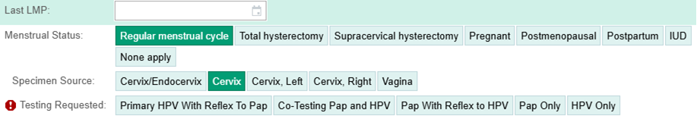

- Order Type: A consolidated "Cytology GYN" (LAB1914) order is used to access testing options.
- Specimen Source: Providers select the specific source; testing options will be listed after the source is selected. Some testing options will be different depending on FDA-approved sources.
- Testing Options: Available selections include:
Testing Name/Choice | Implication
Primary HPV with Reflex to Pap | HPV tested first; a positive HPV will trigger a Pap Test to be performed.
Cotesting Pap and HPV | HPV and Pap Test will be run concurrently.
Pap with Reflex to HPV | Pap Test first; if the Pap is ASC-US, it will trigger HPV testing.
Pap Only | Only a Pap Test will be performed, and HPV testing will not occur regardless of the Pap results.
HPV Only | Only HPV testing will be performed, and a Pap Test will not occur regardless of the HPV results.

- Is Pap Screening or Diagnostic?: An icon will appear next to the question to provide additional detail on when to select Screening vs. Diagnostic.

RECOMMENDATION When ordering cervical cancer screening for patients, utilize the Cytology GYN order and select the desired test based on recommendations outlined in the screening guidelines (linked below). Ensure that questions and relevant clinical history are indicated within the order interface. Patient collected specimen will not be accepted.
Further information on screening guidance can be found at: Screening Guidelines - American Society for Colposcopy and Cervical Pathology (ASCCP).

A Dartmouth Health OBGYN Provider Pearls document is attached to this communication as an example of how Primary HPV can be used for cervical cancer screening based on current recommendations. Individual providers/departments/clinics should review professional guidelines to determine best practices.

For questions or additional information, please contact:
The Cytology Laboratory: (603) 650-5113 or your local laboratory.
The CGAT Molecular Pathology Laboratory (for HPV-specific questions): (603) 650-8257

