To: All Dartmouth Health Providers

From: Isabella Martin, MD, Medical Director of Microbiology
Nicole Loeven, PhD, Assistant Director of Microbiology
Nisalda Carreiro, Microbiology Supervisor

Date: August 31, 2026

Re: New Orderable Test for Arbovirus Antibodies

Effective September 1, 2026, an “Arbovirus Antibody Panel” [LAB2465] is available as an orderable test on serum and/or CSF specimens. When ordered, specimen(s) will be sent to the NH Public Health Laboratory for IgM antibody testing to all four neuroinvasive arboviruses endemic to New England:

Virus | Vector | High Risk Season
West Nile virus | Mosquito (Culex species) | June to October
Eastern equine encephalitis virus | Mosquito (Culex species) | June to October
Jamestown Canyon virus | Mosquito (Culex species) | June to October
Powassan virus | Tick (Ixodes scapularis) | April to November

While the majority of people infected by these viruses are asymptomatic, a minority develop a spectrum of clinical manifestations ranging from acute febrile illness to neuroinvasive disease (e.g., meningitis, encephalitis, acute flaccid paralysis/myelitis). The incubation period from time of insect bite to symptom onset is between 1-4 weeks.

Antibody testing is the first-line diagnostic modality for diagnosing arboviral infection. Direct detection of viral RNA by PCR is generally helpful only in the first 48 hours after symptom onset (7 days for Powassan virus), except in cases of severe immunocompromise (e.g., B-cell depleting therapies). Consider ID consultation in these cases.

Testing for these endemic arboviruses outside of the high-risk season is discouraged. All orders will be reviewed for appropriateness before send out.

In the spring months when ticks are active but not mosquitos, stand-alone testing for Powassan virus can be obtained via a “Miscellaneous Lab Request” [LAB3715] for antibody testing on either serum or CSF or with an order for “Powassan Virus, RNA, Molecular Detection” [LAB2713] for PCR of CSF.

If a patient has traveled outside of New England, testing for other arboviruses may be indicated.

Date of symptom onset is required at order entry:

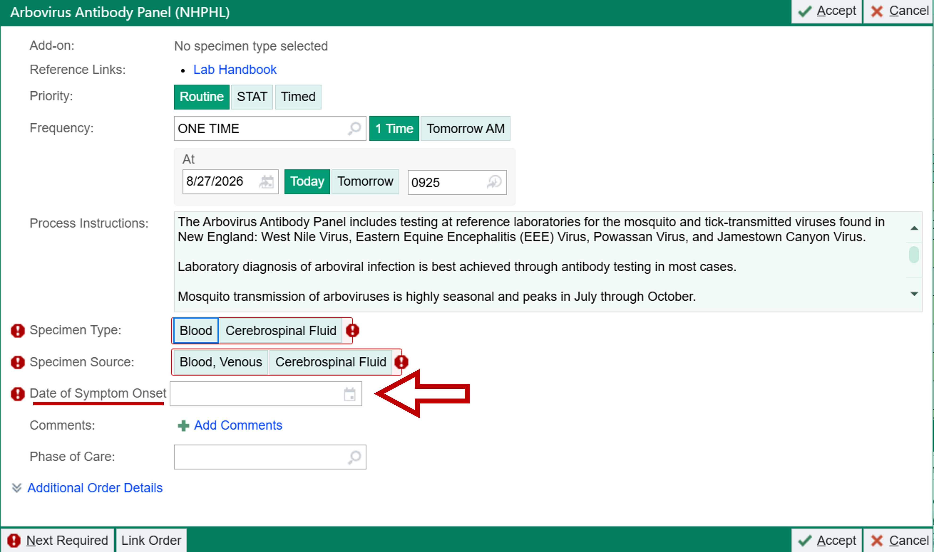

References:

- Piantadosi A, Kanjilal S. Diagnostic Approach for Arboviral Infections in the United States. J Clin Microbiol. 2020 Nov 18;58(12):e01926-19. doi: 10.1128/JCM.01926-19.

For questions or additional information, please contact: Isabella Martin, MD at Isabella.W.Martin@hitchcock.org or Nicole Loeven, PhD at Nicole.A.Loeven@hitchcock.org.

