To: Dartmouth Health Providers

From: Nancy M. Dunbar, MD, Blood Bank and Special Coagulation Medical Director

Brittany E. Condict, MLS(ASCP)^{CM}SBB^{CM}, Transfusion Medicine Service Manager
Rachael M. Chandler, MLT(ASCP)^{CM}BB^{CM}, Blood Bank Supervisor

Date: September 15, 2026

Re: Important change to ABORh Recheck Completion Status in Epic

Background: Type & Screen orders contain a test, “Patient BB History”, that selectively reflexes the ABORh Recheck order based on the result entered. Currently, the test result of “Not Found” indicates that an additional specimen is required and the ABORh Recheck order is reflexed. The test result of “Found” indicates there is previous patient history and an ABORh Recheck is not required. This result triggers the completion of the “ABORh Recheck Progress” test. However, auto results in Epic take an hour to complete after being ordered. The delay in results posting in Epic has led to confusion and unnecessary sample collection.

Update: Effective September 17, 2026, the result options for “Patient BB History” will be updated to reflect the status of the ABORh Recheck. The result “Completed Recheck” indicates no additional specimen is required. The result “Pending Recheck” indicates an ABORh Type Recheck order has been reflexed. Upon completion of testing the second collection ABORh Recheck, a result of “Complete” posts in Epic.

New Test Result | Previous Test Result | ABORh Recheck Required | Example of New Result in Epic
Completed Recheck | Found | No | 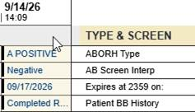
Pending Recheck | Not Found | Yes | 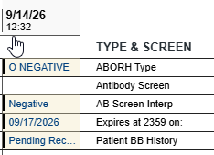  Before  Recheck Completed
Pending Recheck | Not Found | Yes | 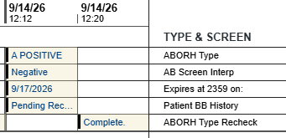  After Recheck Completed

Notes:
- Epic limits displayed results to 11 characters. Hovering over the result will display the full information.
- There is no change to the “Patient BB History” Unnecessary test result. This is used for Type & Screen samples not intended for transfusion, and therefore patients are not evaluated for the necessity of an ABORh Recheck.

For questions or additional information, please contact:
Nancy.M.Dunbar@hitchcock.org, Brittany.E.Condict@hitchcock.org, or Rachael.M.Chandler@hitchcock.org

